**Unlocking Insights into the Global Air Transportation**

**Network with Tableau.**

**1.Introduction :**

This Project titled “Unlocking Insights into the Global air transportation network with Tableau”. **Air transport network** or air transportation network (ATN) is an example of transport networks and spatial networks The nodes of the network are the airports and the links represent direct flight routes between two airports. Alternatively, cities can be considered as the nodes with links representing direct flight connection between them. Air transport networks can be defined worldwide as well as for one region or for one airline company; the scale of the network can be global or domestic.

**1.1 Overview**

**1.1.1 Properties of air transport networks:**

* + - The worldwide air transport network defines communities. These communities are mainly determined by geographical factors. However, in some cases the borders of the communities are different from the borders of geographic regions. Such an example is the community of Europe and Asian Russia.
    - The graph of an air transport network is spatial but not a planar graph. The air transportation network is a complex network which has the properties of small world networks and scale-free networks. The degree distribution of the nodes displays a heavy-tailed distribution.
    - An anomalous property of the air transport networks is that nodes with relatively low degrees may have very high betweenness centrality. It is an important observation related to the robustness of complex networks. According to this finding the critical points of the system are not necessarily the hubs, but some other cities which uniquely provides routes to certain regions.

**1.1.2 Methodology**

In this section, we first give the definition for “alternative pair”. Next, based on several assumption, We Calculate the re-distribution of traffic load when each airports is closed. Using this information , the alternative pairs can be identified. Then we propose the concepts of “alternative strength”and “alternative matrix”,and use “alternative graph” to visualize them.Finally,we present the metric for quantifying the performance decrease of airport network to assess the impact.

**2.PROBLEM DEFINITION & DESIGN THINKING**

**2.1 Empathy Map**

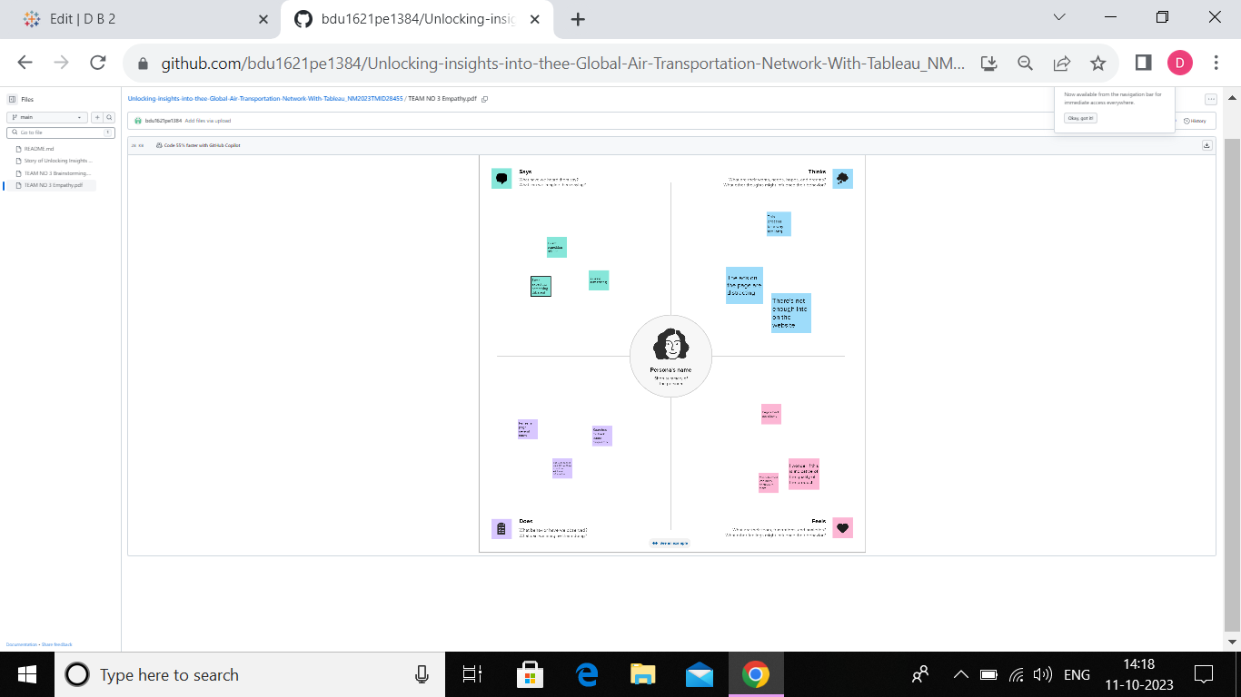

**2.2 Ideation & Brainstorming Map**

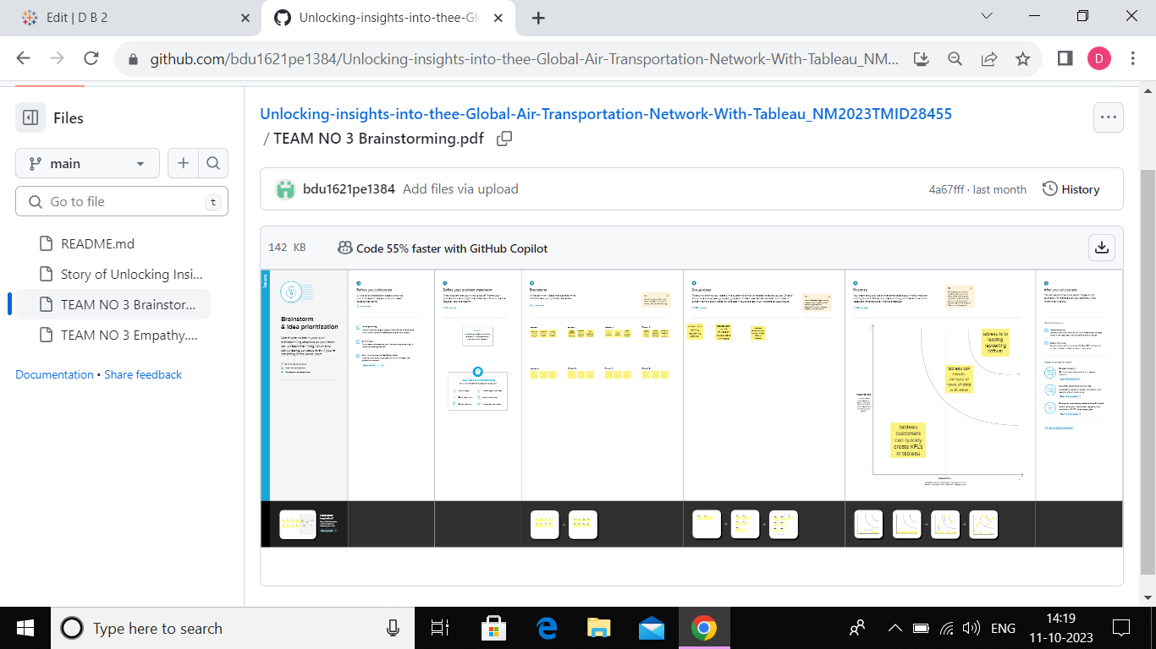

**3.RESULT**

**The available dataset open the door to an array of unique visual depictions. Employing diverse visualization techniaues like bar charts,line charts,heat maps,scatter plots,pie charts,maps,and others,provides a versatile toolkit for developing into project performance and efficiency. These visual representations serve multiple functions,including performance comparison,temporal trend analysis,and showcasing the distribution and relationships between variables.**

**3.1 Visualizations**

**Air Transportation Network**

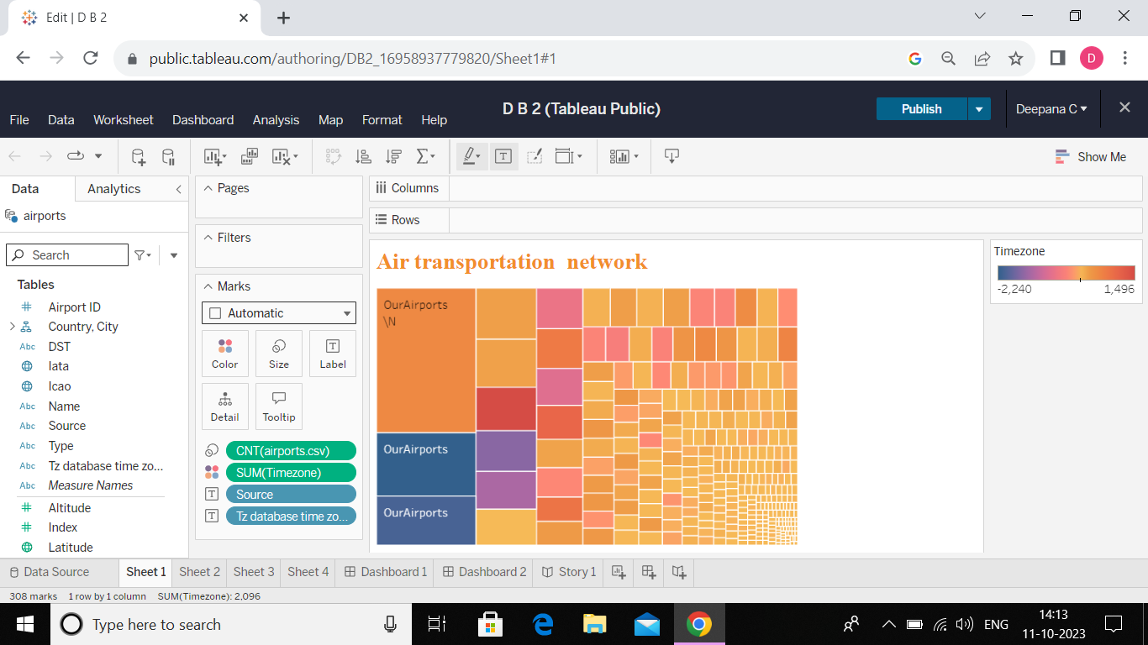

**Global air Insights with Tableau**

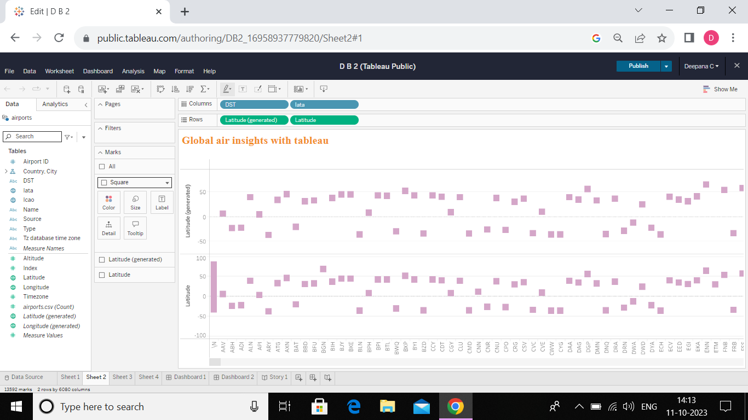

**Transportation**

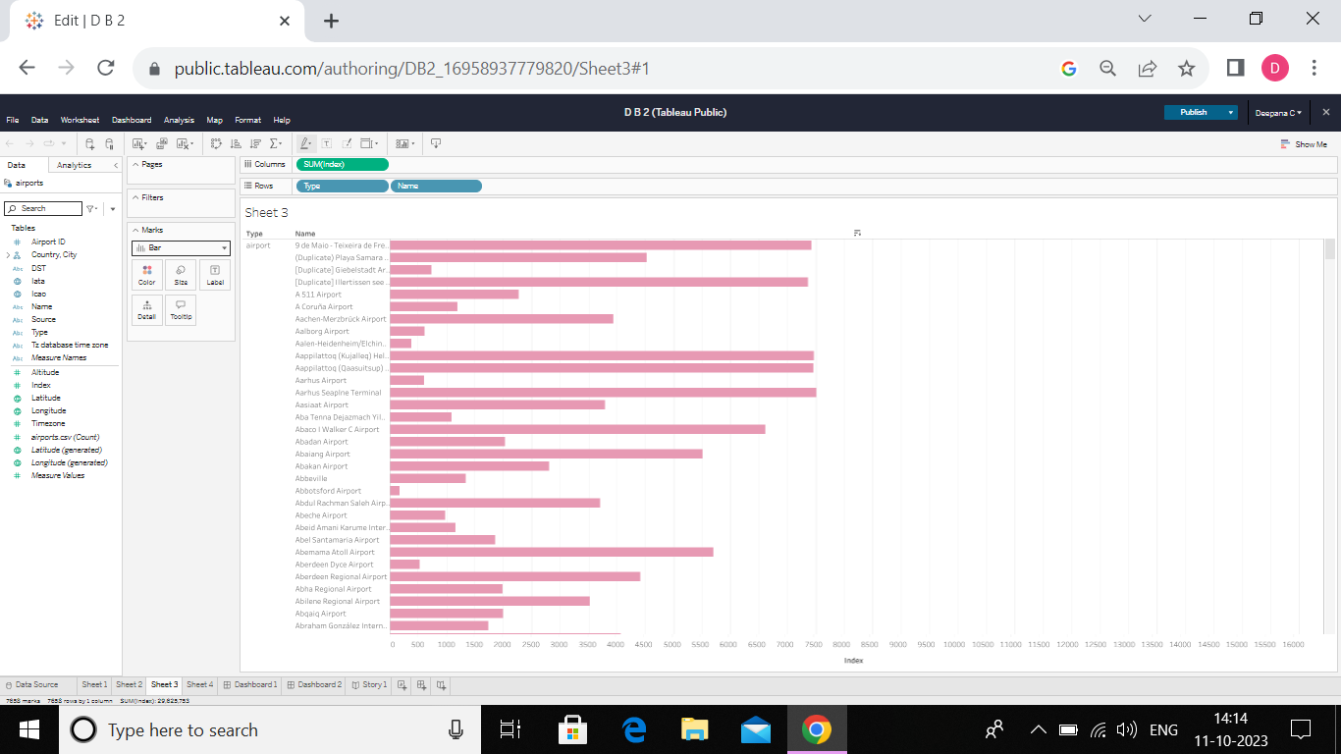

**Unlocking Insights**

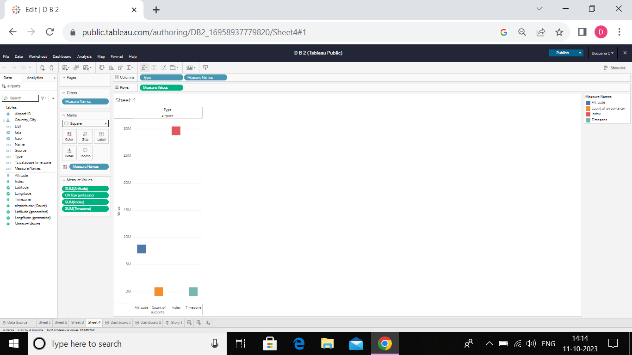

**3.2 Dashbord**

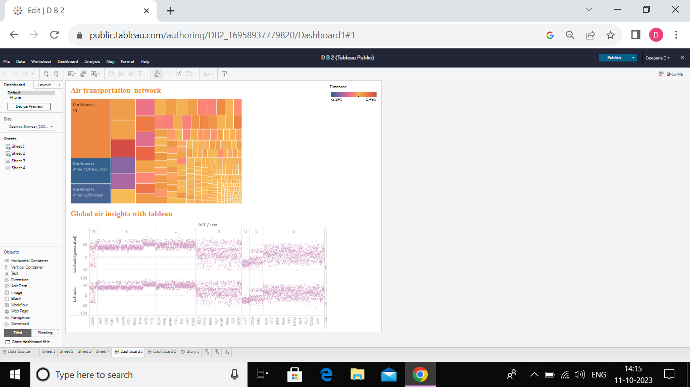

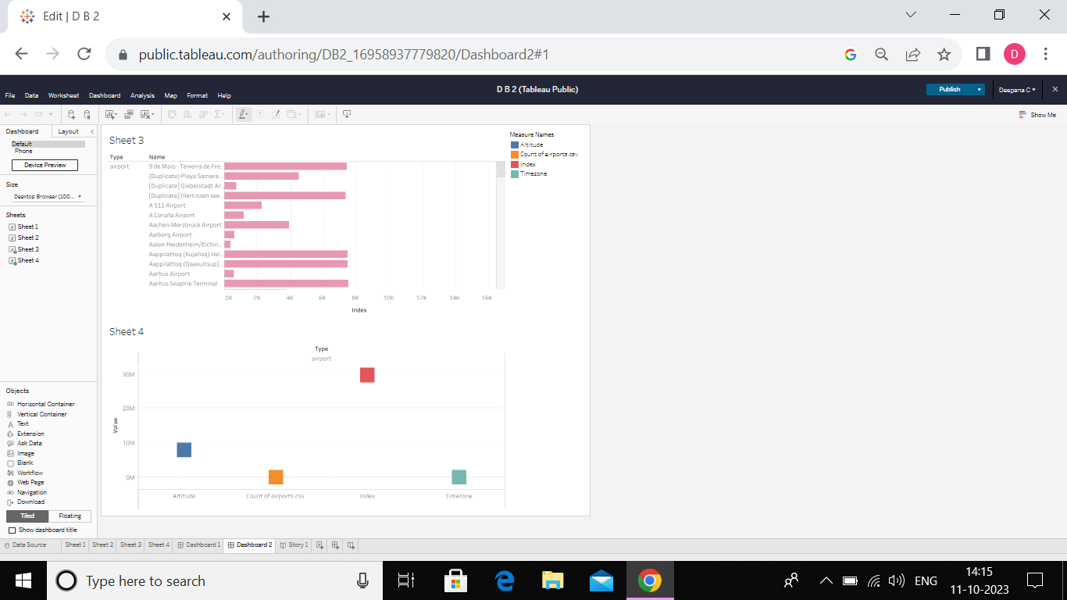

**3.3 Story**

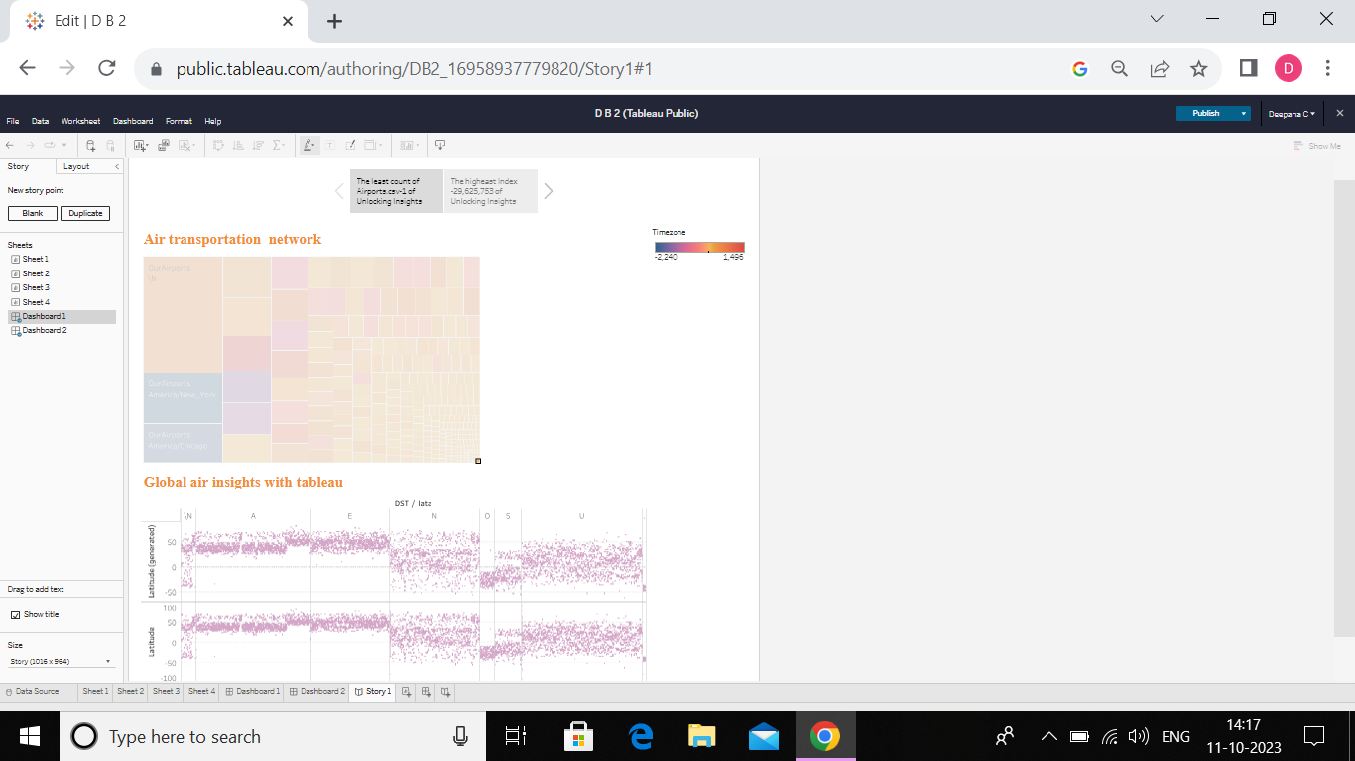

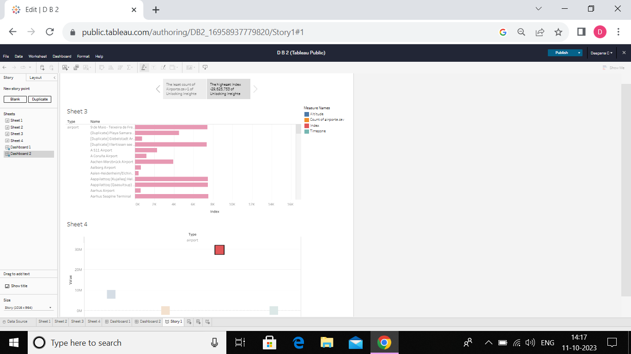

**3.4 Performance Testing**

* **Amount of Data Rendered to Tableau:**

The volume of data presented in Tableau is directly influenced by the dimensions of the dataset.

* **Utilization of Data Filters:**



**No of Visualizations/ Graphs:**

* **Air Transportation network**
* **Transportation**
* **Global Air insights with Tableau**
* **Unlocking Insights**

**4.Advantages and Disadvantages**

**4.1 Advantages**

**Visual Clarity:** Tableau's visualizations provide a clear and intuitive way to understand complex data, facilitating better comprehension of spending behavior and growth opportunities.

**Interactive Exploration:** Tableau's interactive features allow users to explore data dynamically, encouraging a more thorough and customized analysis.

**Time Efficiency:** The tool enables quick data analysis and visualization, saving time in comparison to traditional methods, thus fostering timely decision-making.

**Holistic Insights:** Tableau allows for the integration of diverse data sources, providing a comprehensive view of market insights and spending behavior for a more holistic understanding.

**Effective Communication:** The visual nature of Tableau makes it easier to communicate findings and insights to stakeholders, fostering better collaboration and understanding.

***4.2 Disadvantages***

**Learning Curve:** Tableau has a learning curve, and users who are not familiar with the tool may require training to use it effectively, potentially slowing down the implementation process.

**Cost of Licensing:** Tableau licensing costs can be relatively high, especially for larger enterprises, which may pose a financial challenge for some organizations.

**Data Security Concerns:** Handling sensitive market data requires robust security measures. If not properly configured, Tableau deployments may pose data security risks.

**Dependency on Data Quality:** Tableau's effectiveness is highly dependent on the quality of the input data. Inaccurate or incomplete data may lead to misleading insights.

**Limited Offline Access:** Tableau is primarily an online tool, and while it offers some offline capabilities, full functionality often requires an internet connection, limiting accessibility in certain scenarios

**5. APPLICATIONS:**

Modeling air transport networks aims airline companies to organize their routes in a cost-efficient way and therefore maximize their profits. Air transport network models are also the tool to investigate system robustness. They help to determine weaknesses of the system in case of various kinds of disruptions. Once weaknesses are determined, a substitute node which can support all or part of the traffic load can be identified through the alternative strength for the pair.

An alternative application is modeling human disease networks. Air transport network is used by millions of people every day, therefore it plays key role in the spread of some infections, such as influenza or SARS. In this sense air transport network is a transmitter similar to sexual networks, which is liable for the spread of AIDS and other sexually transmitted diseases.

**6. CONCLUSION**

The "Unlocking Insights" project successfully utilized Tableau to analyze spending behavior.This paper reveals the existence of alternative pair in the defined as a pair is defined as a paie of airports that,if one of them is closed,the other one take over part of its traffic load, We find these pairs of airports important as the network performance will not be affected largerly if only one airport in an alternative pair will worsen the network performance significantly, as no other airports can.

**7. FUTURE SCOPE**

The future scope of Unlocking Insights using Tableau is likely to be characterized by advancements in AI, real-time analytics, data security, and improved user experiences. As the field of data visualization and analytics continues to evolve, Tableau is poised to play a crucial role in empowering organizations with actionable insights for strategic air transportation

**8. APPENDIX**

A. **Source Code:**